FAIRFAX COUNTY  PUBLIC SCHOOLS | 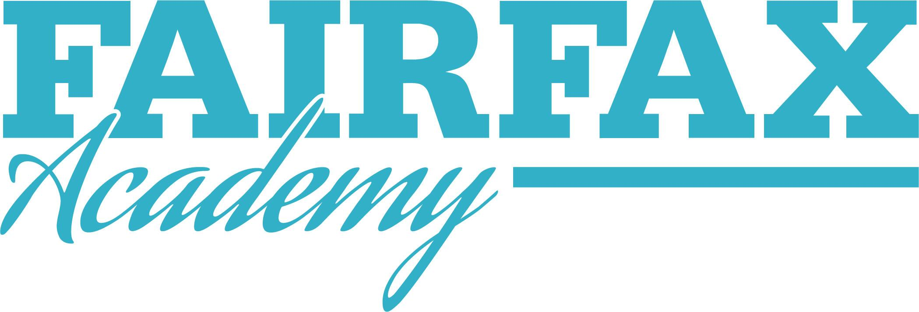  Fairfax Academy  3501 Rebel Run  Fairfax VA 22030
2019-20 ACADEMY TRANSPORTATION AGREEMENT
This form is required for students that do *not* attend Fairfax High School.

PLEASE PRINT:
Student Name ________________________________ ID# __________ Base School: _______________

PARENT/GUARDIAN – Please select ONE of the following transportation options:

SHUTTLE BUS TRANSPORTATION PROVIDED BY FCPS

My student must ride a SHUTTLE BUS between the base school and Fairfax Academy for the 2019-2020 school year. I have read the Transportation information that outlines the provisions for school bus transportation between the base school and the Academy. I understand these procedures and agree to my student using this service and following all the guidelines therein.

Parent/Guardian Signature: _________________________________________ Date: _________________

OR

PERMISSION TO DRIVE and/or RIDE IN A PRIVATE VEHICLE *
(back side of this form must be completed)

I have received the memo outlining the Fairfax Academy driving and parking policies for the 2019-2020 school year. I understand that Fairfax County Public Schools has no liability for students driving or riding in private vehicles to and from class. My student has my permission to (please initial each applicable statement):

_____ Drive only themselves - Students who drive must complete the insurance info on the back of this form AND submit a Parking Tag application.

_____ Drive and carry only the following rider(s): _________________________________________

_____ Ride only with the following driver(s): _____________________________________________

Parent/Guardian Signature: _________________________________________ Date: _________________
*Virginia’s legal passenger limits for beginning drivers must be observed. Be aware that under the Virginia law a driver under age 18 can carry only one passenger in their car while driving.

